Easter Sunday 2020
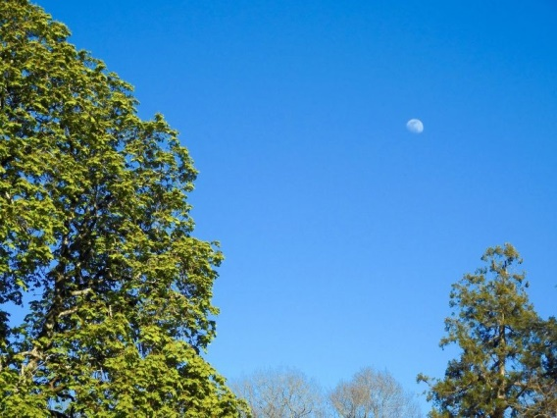

As I write this, I am still feeling the surprise of feeling the brilliant light of the huge moon in the early hours of this morning. Moonlight always feels as if it gently floods your body and then strokes the mind. I am distracted, however, from thinking about the lunar feast of Easter, the link with oestrogen and the forever melting and growing phases of the moon. Distraction comes from a continuous raucous noise, like a football crowd celebrating a championship win that is pouring into my room through the open windows in front of my desk looking out at the lake at Bonnevaux. Frogs in full choral disharmony. As the book I consulted puts it, boy frogs awaken from their hibernation with one thing on their minds and lady frogs swollen with spawn lay it and before you can blink it is fertilised.

I rose from the dead after drawing the sting of death and loosing the bonds of hell.. for lo the winter is past, the rain is over and gone. The flowers appear on the earth. I have risen from the dead, I have offered peace (Origen: Homilies on Song of Songs)

Spring. The calm peaceful, influential cycle of the moon which shape the religious and farming calendars and our moods. The frenzied fixation and impatience of the mating rituals. Energy passing upwards in the body and bursting into spirit.

Resurrection happens both in nature and in our psyche which reflects it. Mis-stepping in the dance between the inner and outer rhythms disturbs everything. Many have understood this through their harsh encounter with the virus, one face of nature during the past weeks. The difference between the Resurrection of Jesus and the biological cycle of nature is that in him the cycle of death and rebirth is not repeated but transcended. True, we continue to experience many deaths and rebirths, as always, the deeper the death the higher the rebirth. But through each cycle in our personal and collective lives, we can better breathe in the light of the risen, never to die again, Jesus and lose and find ourselves in him.

The corona crisis has meant death for many individuals, myriad kinds of suffering and perhaps the death of a way of life. We have long known it was unsustainable. Growth out of control is cancer. Easter reminds us that we do not need to fear change or death once we are committed to real life. Our spiritual path, whatever form it takes, is that commitment. As we

enter into the cycle of death and resurrection more thoroughly, we become more aware of its universal truth, that it is the model of all being. We begin to appreciate what Mystery is…It is the cycle upon which each half-hour of meditation is based: death to the possessiveness and triviality occupying our ego and a rising to the liberty that dawns when we find ourselves by looking fully at the Other…We are dying and rising to new life every day.. Yet it is also true that there is only one death and one rising which Jesus underwent for all creation. (John Main Word into Silence)

