Monday Lent Week Five
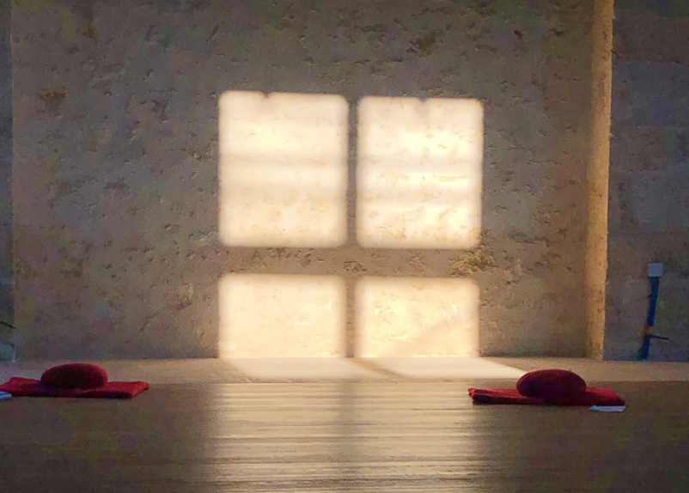

What’s normal? Once I was talking with someone who had been greatly angered and felt deeply betrayed by a friend. The friend had, I thought, acted badly. Yet, it was easier for me to be ‘objective’ and think ‘well, maybe they didn’t want to hurt this person and maybe they didn’t really know what they were doing’. This is much easier to say when you’re not on the Cross yourself.

Jesus reached the highest objectivity, not the false one most of us claim to speak from. It is reached at the base of the greatest subjectivity – when he knew himself totally and was about to give up his spirit to his source, ceasing to be separate in any way, and abandoning any clinging to himself. He was on the Cross at that moment and said, ‘Father forgive them for they know not what they are doing.’ Interestingly, he didn’t say ‘Father, I forgive them...’

When it is “I’’ doing the forgiving, there is too much personal attachment to the pain and the drama of forgiveness. In calling forth forgiveness for his enemies’ appalling and vicious ignorance, from the ground of being, he was connecting to the source itself. His last words teach us where he had reached and what we should aim for.
Anyway, back to this life. The person I was speaking to, who felt betrayed, was analysing and condemning the person who had hurt her. We all do it, trying to understand how this could have happened, explaining it in a way that blames but pretends to be objective. We use psychological language for this today most of the time. Maybe there is some truth in the psychological assessment we make of others. But it may not yet be a truth we have earned the right to use. This becomes obvious when we say something like, ‘it’s just not normal. There’s something wrong... abnormal about them.’ Jesus didn’t say of his final predicament, ‘it’s just not normal.’ In fact, it was only too normal: that we blame others and crucify them in order to protect ourselves from the truth. There’s nothing more normal in human relationships and institutions than scapegoating.
It’s hard even for the most devoted Christian to say exactly what the Cross does for the world and why it matters. In fact, outside the radiance of the resurrection, it’s impossible to do so. But, one helpful particle of the total truth of the mystery of his suffering and death is that it exposes the falsehood, the self-deception, the terror of the truth that hurts us, which scapegoating others is one way of running away from.
Suffering, and we are all experiencing it in this crisis, should be avoided or reduced, if we can. But if we can’t, let’s learn from it. Let’s hope that after this passes and we begin the recovery, we will have a better understanding of what ‘normal’ really means. Normal use of time, normal weather, normal relationships. How we use this time can help us find the centredness and balance that the Cross also symbolises. Then we will be less prone to blame and more ready to act well. Just by being who we are (like Jesus did) we will be agents of change for the normal that is real.
Tuesday Lent Week Five

Where is our memory stored? The materialist’s answer is in the hippocampus of the brain for long-term memories and the neocortex of the brain for what I had for dinner yesterday. A more subtle answer that takes the spiritual dimension for real (not just as an accident of the brain) would say that all memory is stored in the deeper level of consciousness. As our Buddhist dialogue partner in the recent inter-contemplative dialogues, Alan Wallace, said we don’t think that the memory of a computer is stored in the keyboard. Why should we think the brain makes us conscious?

An old aunt of mine suffered Alzheimers for ten years and could not communicate at all. Her daughters decided they would tell her that her husband, their father, had died although they knew she would be unaware and unresponsive. She continued to jabber meaninglessly as they told her, but then, tears rolled down her cheeks. That may not prove anything scientific about memory; but it suggests something about consciousness surviving the atrophy of the brain just as it has been shown to survive the clinical death of patients under medical care.

To see someone whom we have lived with and loved for a lifetime lose their memory and drift away from us is dying while alive. We pass through deaths at many levels of intensity in a lifetime, but this must be one of the worst. And yet, in this too, there is a substratum of consciousness that connects us, even when all the signals we exchange to show that we recognise and care for one another have flickered out.

The persistence of deep memory – and love is a kind of memory continuously remembered and renewed – does not negate death. In a way it makes death all the more final and terrible. Yet it transcends death and shows life as the great constant. Life is inextinguishable. Consciousness itself is life and memory shows love to be stronger than death.

Personal relationships teach us this. So do great spiritual traditions which are a transmission in a stream of consciousness of a living memory that connects us to our source while it carries us forward on our individual journey. For all of us today our individual journeys in life are connected by the threat and fear of the coronavirus. For some of us it has already meant the death of loved ones. For all it triggers the awareness of our mortality and the uncertainties of change we cannot control.

In such dark times, however, a collective memory, suppressed by hyper-distraction, becomes conscious again: the memory of life experienced as a spiritual journey beginning and ending in mystery, full of inexplicable pain and joy but full of wonder. It is wonder in the end that frees us from fear. We are first exposed to our real predicament: of not having a spiritual path in times like this, lacking a source of meaning, not seeing the spark of life hidden in the darkness of our deaths. All these are symptoms of another virus rampant in our materialism and delusion. To remember this is to beat the fear of death and dying.

Wednesday Lent Week Five

Many people today are becoming oddly aware that in life before the virus they had forgotten something obvious. That above everything else life is, a spiritual journey. Many are remembering that a spiritual path is necessary to remain conscious through all the excruciating uncertainties and extremes, that life is a spiritual journey.

And for those who before struggled to be faithful to a regular spiritual practice, to meditate twice a day, it is clearer that a spiritual path is more than a lifestyle choice: it is the ‘one thing necessary’ (Lk 10:42) To remember this is to become conscious again. To be conscious is to be alive. Our best chance of surviving is to be awake. This is the work of the humble practice of daily meditation and the mantra.

Thank God for the internet and social media. Whatever bad use we made of them before the virus we are now discovering how they can be a lifeline to meaning, to connection. Depth and meaning come through inner connection with others, being reminded by them of the necessary grace of friendship. Shared spiritual practice does not make us perfect; but it builds community.

Feeling connected to a community builds resilience and deepens peace through these lonely, often bewildering days of social isolation. The response to the WCCM’s A Contemplative Path through the Crisis has been amazing. A surge of people have been signing up to join the path and receive the teachings, short videos, audio and print media from which you can choose what will best help you at that moment. Above all it supports practice with a sense of community. We follow a spiritual path and take the responsibility for ourselves. But the solitude to which it leads, reveals the deep connections we have with all others. It is not a club, but an inclusive community is especially felt between who follow the path together, supporting, being supported, now giving encouragement, now receiving it.

To have a spiritual path enriches us with the gift of spiritual friendship. No price, no membership fee can match this gift, healing the isolation and loneliness which are also viruses long at work in our culture. A path also feeds and calms the mind, giving us essential tools and insights to help us endure when we encounter suffering, disruption, loss or fear. Without a path we are so overwhelmed. Yet we are never far from it. We have. A sense of homecoming when we connect with it again.

For the first time most churches in the West are closed for public worship because of the coronavirus. They have been becoming emptier for a long time because the spirit and form of worship increasingly seemed, especially to the more free-thinking younger generation, empty of meaning, lacking connection with an inner spiritual path. Religion without connection to a contemplative practice, eventually merges with external ritual and outward works. It lacks heart, the most precious dimension of human existence.

